**Date: 15th April 2023**

Solar Secure Solutions Web development training

---------------------------------------------------------------------------------

**Session 1: What is a web development?**

As per Wikipedia, Web development is a work involved in developing a website for the internet (World Wide Web) or for the intranet (private network)

………………………………………………………………………………………………………………………………………………………….

**Session 2: Understanding the servers**

A server is nothing but a computer program or a device that provides functionality for other programs or devices, called “clients”. This architecture is called **client-server model**.

Basically a server is a destination where a website is kept for people to access. Even our laptop can be server if website is stores but a server should be on and connected to the internet all times for peoples to access that website

………………………………………………………………………………………………………………………………………………………….

**Session 3: Client-Server Model:**

Server side development is a technique used in web development which involves employing scripts on a web server which produces a response customized for each user’s (client’s) request to the website. (for eg: server sends a differently designed web page for mobile user, different designed web page for tab user or computer user likewise) see below image.

Client side code: Program that runs on the client side machine (browser) and deals with user interface/display and any other processing that can happen on client’s machine like reading /writing cookies actually forms the client side code.

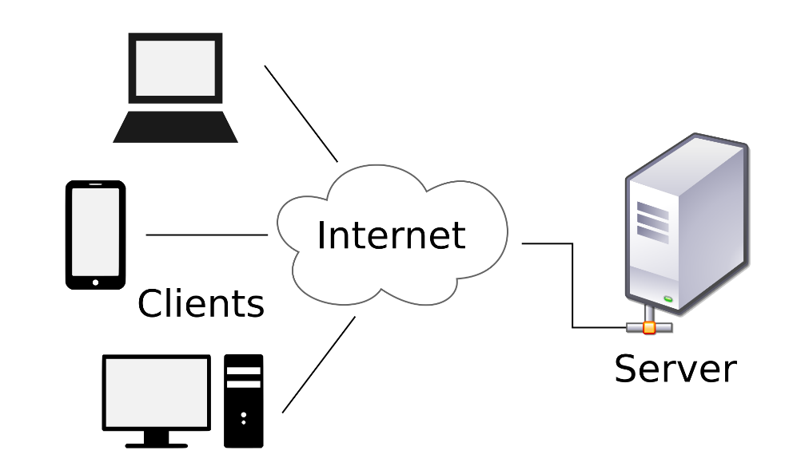

………………………………………………………………………………………………………………………………………………………….

**Session 4: What is web domain?**

A domain is a name of your website.  
A domain name can be name of your business as well.   
If it is a personal website then you can use your name as domain name. You have a option to purchase a domain name for 1 year, 2 year or 10 years (based on your requirements)

Tips:

1. Keep it short (max 2-3 words)
2. Avoid numbers & hyphens
3. Make It easy to type
4. Make it easy to Brand able
5. Use correct domain name extension

(Prefer .com extension)

1. Check availability of your domain.

How to check domain availability?

1. Leandomainsearch.com
2. Bustaname.com

………………………………………………………………………………………………………………………………………………………….

**Session 5: Creating web pages using tools in chrome**.

Discover inspect tool on web page, to reveal the various tags used for building the web page.

………………………………………………………………………………………………………………………………………………………….

**Session 5: Sample HTML Code**.

In this session lecturer discussed abouthtml format, indentation of html tags, underline a particular text and lastly title of the web page

………………………………………………………………………………………………………………………………………………………….

**Session 6: Some HTML tags**

|  |  |
| --- | --- |
| **HTML Tag** | **What they do** |
| H tag | h1, h2, h3, h4, h5, h6 used for writing heading on page |
| div | Used to create containers which separates contents on web page |
| p | For writing a text or paragraphs |
| a | Used for creating links |
| br | Adds a line break |
| hr | Adds a Line separator |
| span | Used to group a part of text |

………………………………………………………………………………………………………………………………………………………….

**Session 7: Commenting in HTML**

HTML comments are written as <!-- text -->

………………………………………………………………………………………………………………………………………………………….

**Session 8: Creating Lists:**

Created a list

There are 2 types of lists

1. Ordered list: which is denoted by <ol>. Can start this list with number, roman number, alphabets by using start attribute
2. Unordered list: which is denoted by <ul>. can start this list by various bullets

………………………………………………………………………………………………………………………………………………………….

**Session 9: Dealing with the images**

Image can be inserted with **img** tag. Img tag has its own attribute called **src** which stands for Source in which we specify the path of the image. Img tag also has **alt** attribute which used display name of the image

…………………………………………………………………………………………………………………………………………………………..

**Session 10: Making Table:**

We can create a table in an HTML web page using table tag. In which

If we want give heading , use th tag

For creating row use tr tag

Ad for table data use td tag

………………………………………………………………………………………………………………………………………………………….

**CSS Section:**

**Session 11: Default styling (User Agent Style Sheet)**

Whenever we define any html element in the browser there is default style sheet comes in the browser which is known as **Default styling** **(User Agent Style)**

………………………………………………………………………………………………………………………………………………………….

**Session 12: Inline Style:**

Inline style means we have to define styles to same line separately to each element where we have defined that element

…………………………………………………………………………………………………………………………………………………………..

**Session 13: Id’s & Classes:**

Id’s & classes are the attributes of the HTML elements

Where Id should be unique and classes can be used one or more sometimes.

…………………………………………………………………………………………………………………………………………………………..

**Session 14: Internal & External Styling**

Inline styling: writing css in the same line as the HTML element

Internal Styling : Internal styling can be written in same html file in style tag

External Styling : Maintain a separate CSS file and insert that CSS file into an html file by using link tag

…………………………………………………………………………………………………………………………………………………………..

**Session 15: CSS framework – Introduction to Bootstrap**

……………………………………………………………………………………………………………………………………………………………

**Session 16: Applying Bootstrap in our Home Page**

…………………………………………………………………………………………………………………………………………………………..

**Session 17: HTML Section**

Understanding html in detail